Generation Unlimited
Youth Challenge
Facilitation Guide


Pre-bootcamp Training Session
L’atelier d’orientation est un événement d'une demi-journée à une journée complète qui aide les jeunes participants à se préparer pour les étapes à venir. Il comprend une introduction du calendrier détaillé des ateliers de conception, des activités de consolidation de l’esprit d’équipe, des rencontres avec des mentors et une introduction aux méthodologies du « Design thinking » et à l'évaluation des besoins de la communauté (community needs assessment). C'est aussi l'occasion de répondre aux questions logistiques que les jeunes pourraient avoir avant les ateliers de conception.

Après cet atelier d’orientation, les participants doivent avoir les informations sur:
- Le calendrier complet de l’atelier de conception
- La logistique et informations pratiques sur l’atelier de conception
- Le règlement d’ordre intérieur (respect du temps, utilisation des téléphones, travail d'équipe, toute autre règle qui peut exister)
- Les Critères sur lesquels les équipes seront jugées.
- Et un kit (t-shirt ou autre chose que les jeunes reçoivent)

Agenda de l’atelier d’orientation
11:00 – 11:30 | Ouverture – Accueil des participants
11:30 – 12:00 | Présentation PowerPoint- Introduction sur le Youth challenge
12:00 – 12:30 | Rappel des critères (âges et autres) et vérification des pièces d’identités
12:30 - 13:00 | Séance de question réponses
13:00 - 14:00 | Analyse de chaque projet et la situation des membres par rapport a la mise en oeuvre
14:00 - 14:30 | Briefing sur les étapes suivantes- Présentation du Calendrier local et global
15:00 | Fin

PHASE 0: EMPATHY
Expectations and Values

Objective: Participants understand the values of the Youth Challenge and are familiar with the expectations, rules, and responsibilities they will have to subscribe to throughout the process.
<Time: 20 minutes>

After having had the introductory session, discuss expectations and values and how they can work together in the coming days.
- Be Human Centered: Have the desire to understand deeply what motivates individuals and work relentlessly to find what they need.
- Be Collaborative: Believe in the power of bringing together different points of views to find an out-of-the-box solution.
- Embrace Failure: Accept that failure is part of the process and look forward to learn from it.
- Be Empathetic: Put one’s self in the shoes of others in order to see the world from their perspective.
- Be Experimental: Be excited about learning by doing things for the first time.
- Play: See the world with a child eye, question everything, have fun!
Design Thinking

Objectives: Participants learn the basics and fundamentals of design thinking and human centred design processes. this introductory module will shed light on how the Youth Challenge will unfold in the following sessions.
<Time: 40 minutes>
- Continue by showcasing the characteristics of the human-centred / social innovation process so that participants better understand the process and their role moving forward.
- A good place to start is by showing the following graphic, simply outlining the iterative process of Design Thinking.
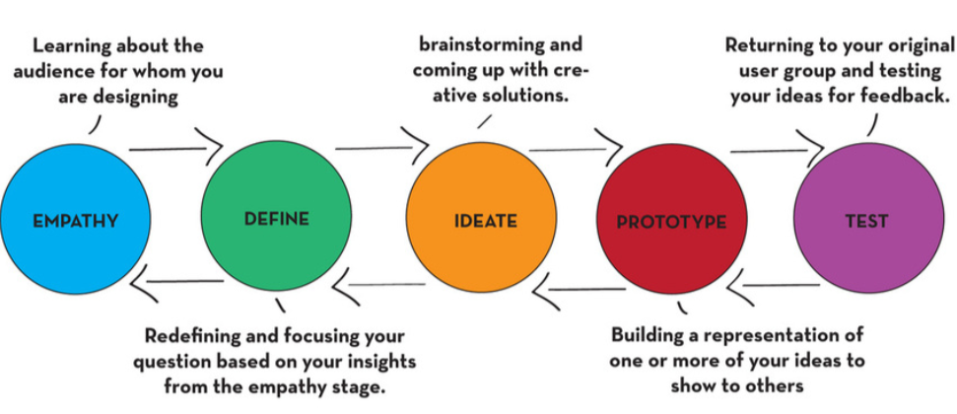
- If you have time, you can delve deeper into Design Thinking, a good tool to use is this presentation on the Introduction to Design Thinking.

Stakeholder Mapping

Objectives: Participants will become familiar with the stakeholder mapping tool that will help them understand the key people that have a stake in the challenge they are trying to solve.
<Time: 45 minutes>

- Explain that to be able to understand the problem you are trying to solve, we need to understand who the stakeholders are.
- Tell them that the purpose of mapping stakeholders is to identify who is impacted by, associated with, or contributes to the problem.
- Ask the team to think about who is affected by this problem.
- Continue by asking who are the stakeholders that can affect this problem or can support in finding a solution
- Ask them to use sticky notes and write each stakeholder on them.
- Prioritise the stakeholders. Which of these stakeholders are essential, important, or interesting for your project?
- Visualize the stakeholder on a map. Sketch the stakeholders visually onto the Stakeholder Map according to the prioritization - the more important they are, the closer they are to the middle of the circle. (You can also draw on the relationships between stakeholders. What does each stakeholder provide to the other (product, money, trust, love, smile, etc.)?

Community Needs Assessment

Objectives: Participants will become familiar with design thinking techniques that help to assess the needs of the community.
<Time: 45 minutes>

- This afternoon teams will be going into the community (or doing field research by phone depending on the safety situation) to assess the needs of the community using the Need Finding Matrix tool.
- The tool’s main purpose is to uncover insights through (1) Observations (2) Engagements (3) Immersions.
- Facilitators should explain the tool to young people and help them to fill it out, thinking about where and what they will (i) observe, (ii) immerse themselves in or (iii) engage with. For example, if a team wants to better understand the problem with users’ experience at the bank. They can:
- Immerse: Try to open a bank account themselves or withdraw money and take note of their pain points during the experience
- Engage: Interview people waiting at the bank or as they exit the bank. Interview tellers/bank employees. Here the students must create an outline for their interview questions
- Observe: Students can so silently observe and take note of interactions at the ATM machines

NOTE: The groups do not have to add an example for each of the 3 categories, how they will go about their Need Finding exercises will depend on what assumptions they are testing. Sometimes they cannot observe, sometimes they cannot engage and that is fine. It is also important (particularly if working with under 18s) to consider any risks associated with undertaking the Needs Assessment.

Depending on the chosen community issue, the team’s concoction of mechanisms will look different. considering that the “Engage” mechanism of the “Need Finding” Matrix employs direct interaction with community members, the teams should be able to practice it before going to the field.

Empathetic Interviews

The purpose of this exercise is to prepare for undertaking interviews. You might wish to use different interview preparation tools.
<Time: 45 minutes >

- Explain that empathy is the experience of understanding another person's condition from their perspective. Empathy can be a choice. We have to choose to be intentionally empathetic in our role as social innovators. Empathy is the starting point for social innovation as it opens us up to understand how people or communities experience their world; both the good and the bad.
- Explain that as aspiring social innovators, we need to develop the skills of being empathetic. This means understanding what other people are feeling and being able to respond effectively.

In this group exercise, the participants will practice the key skill of interviewing and developing empathy.
- Ask each team’s members to assign themselves to one of the 3 roles below. If they have trouble assigning themselves, support them.
  - Interviewee – (person being interviewed) – this person puts themselves in the shoes of a person that might be affected by this issue. In the interview this person should speak as though they are a person affected by this issue – for example they should use “I” statements.
  - Interviewer – this person(s) will ask questions to understand the challenge that the interviewee is facing
  - Observer – this person(s) will watch and observe the interaction to gain insights about the person being interviewed, and also to give feedback to the interviewer
- Ask the group to agree on the types of questions they will be asking during the interviews, and then ask them to think about the type of person that is affected by this issue – someone who might be quite different from them. It could be an older person and/or a person of a different gender or background.
- Ask the team to think of the Stakeholder Mapping exercise previously conducted and identify a person who might be directly affected by the issue or problem – we will call people in this group ‘Target’ stakeholders
- The person in the Interviewee role should imagine a fictitious person that would fit in the Target group and ask themselves the following questions to help to understand what it is like to “live in their shoes”– the goal is to imagine as much as possible about their lives and what is important to them.
  - Are your stakeholders male or female?
  - What age are they?
  - What is their job, are they a student?
  - Where do they live?
  - What size of family do they have?
  - How does this issue impact them?
  - What are their goals, motivations and what frustrates them?
- The person being interviewed will try to put themselves ‘in the shoes’ of the person that they think might be affected by this issue. The interviewee will tell the interviewer who they are, their name, age, where they live, and other details that they can imagine.
- Give participants a copy of the Guidelines for Interviewing worksheet and talk about how to approach interviewing.
- Now, it is time to start the interview role playing! Please note that while there are suggested questions and areas for the interview to cover, you should tell participants to be curious about what appears to be important to the interviewee and ask questions accordingly.
- The interviewer should interview the interviewee for 5-10 minutes with these guidelines:
  - Begin by saying thank you for their time and asking them how they are doing.
  - Explain who you are and what the project you are working on is, explain why this interview is happening and how this information will be put to use.
  - Try to find out how this issue affects this person, such as what are they worried about, pleased about etc.
  - Find out what is important to them now and in the future.
  - Ask how this issue affects their lives.
  - Do they see opportunities to improve or change the situation?
  - How might they use the resources they already have in the community to address this problem? This could include: expertise of a certain type, buildings, spaces, certain community values that need to be brought back, or even things that don’t currently look like resources such as food waste or garbage.
- The role of the observers is to observe what is happening in the conversation and to give thoughts and feedback on the exercise.
- After 5-10 minutes, ask the interviews to stop and ask them what they noticed, what worked well and what they might do better next time.
- If there is time, have the team rotate their roles and re-do the exercise once more
- Each time the group rotates, discuss the following debrief questions:
  - Interviewer – What did they find out was important to this person?
  - Interviewee – How did it feel to be in the shoes of another person and how did it feel to be interviewed? Did you gain any insights into how the problem impacts this persona?
  - Observer – What did they observe or learn from the interaction?
Explain to the team that the community interviews will look similar to this exercise. for the community interviews, make sure that safety of the adolescents is upheld. Guide the adolescents to conduct the interviews in pairs and whenever possible, have a mentor accompany them.
Reference documents:
Appendix 4.3.1 Stakeholder mapping
Appendix 4.3.2 Needs Finding Matrix
Appendix 4.3.3 Guidelines for Interviewing
Introduction to Design Thinking.

2. Bootcamp Facilitation Guide : A Facilitator’s Guide
It’s on! A three-day (depending on what the CO has decided, the length of the bootcamp may be different), crazy fun-packed weekend with [fill country]’s finest Youth! We’ll welcome youth from all over [fill country] in this second edition of the Youth Challenge Bootcamp. We have the utmost belief in your capabilities as Facilitators. Some of you have prior experience in mentorship and facilitating similar workshops but you might feel the need for inspiration and advice so to that end, we’ve put together this manual so that you have something to fall back on.

This guide is written for the facilitators who are supporting each team. There is an assumption that there will be a main facilitator guiding the overall group and that each team will have someone who is working directly with them to support them through the bootcamp.

If you did not run a pre-bootcamp, you will need to find ways to undertake research as part of the main bootcamp and thus, the length of time that young people spend in the bootcamp may be longer.

At different points during the bootcamp you will be asking teams to record their results into a project plan template. This document can help the teams as they progress towards prototyping, piloting, and project implementation.

As you contextualize the toolkit to fit the needs of the target group specific to your country, you are offered a series of tools to deploy during the Youth Challenge. The ideal situation is where all of the tools laid out below are utilized during the Youth Challenge - this is because each tool offers a specific skill-set to the participants and helps them craft the best versions of their solutions. In cases where the time is limited or the target group necessitates working longer on the different tools, then you may choose to omit some of the optional tools. Should you have other tools that have the same outcome but you feel would work better within your context, in coordination with your Youth Challenge focal point, you may feel free to use them.

The following agenda is just a suggestion. COs are encouraged to build their agenda of the bootcamp depending on the context and the target group with which you are working. You may want to re-evaluate the pace of the agenda based on the pre-bootcamp experience.
DAY 1 OF BOOTCAMP

Day 1
09:00 – 09:30 | Arrival and Registration
09:30 - 10:30 | Introductions, networking, energisers
10:30 - 11:30 | User Research Reflections
DEFINE
11:30 – 12:30 | Problem Tree
12:30 – 13:30 | Lunch
13:30 – 13:45 | Energizer
13:45 – 14:45 | 5 Whys
14:45 – 15:15 | Target Group and Stakeholders
15:15 – 15:45 | Break and Energizers
15:45 – 16:45 | Personas
IDEATE
16:45 – 17:45 | Design Challenge
17:45 – 18:30 | Brainstorming - part 1
18:30 – 19:00 | Wrap up and energizers
19:00 – 20:00 | Dinner / evening entertainment
MUST - DEFINE PHASE
Before entering into the design thinking process, it is important to reflect on how the user research field work went. The questions, length, and format of this phase will largely depend on the way that the pre-bootcamp was conducted in [country].
<Time: 60 mins>

Begin by prompting the team on the following questions:
- What have they learned during the user research phase?
- What was different from the empathy interviewing exercise done during the pre-bootcamp sessions?
- What information came out of the interviews that the team was not aware of?
- How has the field work and interviewing process changed their outlook on the initially identified community problem?
These insights will set the tone to start thinking of the problem in a more in-depth way.
MUST - Problem Tree

Objective: Enable participants to assess the causes and symptoms of the problem they are trying to solve.
<Time: 1 hour>

- Explain that a thorough understanding of the problem, causes, and consequences is key to helping us meet a need and build successful solutions.
- Introduce the idea of a “Problem Tree”, and begin to recreate the diagram on the flipchart paper.
- Review the problem that the team is trying to address. Encourage the team to phrase the problem concretely and specifically, then place the problem the team has identified in the “trunk”.
- Explain to the team that the first task is to think about the consequences of the problem. Propose one consequence of the problem, writing it on a sticky note, and adding it to the diagram as a branch.
- E.g. If the problem is early marriage, consequences might be early pregnancy and health problems, unfinished education, domestic violence, economic disempowerment, etc.
- Explain that the next task is to identify causes of the problem. Have teams review the causes they identified on their application.
- Think aloud: after conducting my user research, do the causes I initially identified still feel valid and correct? Choose one cause and write it on a sticky note, explain the relationship between the cause and the problem.
E.g. With early marriage, one cause might be parents forcing girls to marry; another might be girls feeling they don't have alternatives, etc. - COs and their implementing partners are highly encouraged to adapt and modify the examples throughout the toolkit to fit the context in which the Youth Challenge is being deployed.
- Help the team think of additional consequences, writing each on a sticky note, and group related consequences. Create a new “branch” for each group of consequences. Shoot for 3-5 consequences.
- Have teams review the causes they identified on their application, asking if the causes they identified are supported by the research, and remain valid and correct. Have them write additional causes on sticky notes, and place them at the top of the “roots, nearest the trunk. Each cause becomes one root.
- Ask teams to look at their user research and identify any other causes that emerged through their interviews. Have them write these down, and add them as roots. Aim for 3-5 causes.
- Explain to teams that their design process is iterative; they can always come back and add new causes or consequences, or even remove them, as their understanding of the problem progresses.
OPTIONAL - 5 Whys
<Time: 1 hour>

- Explain that many of the questions the teams asked in the research had to do with “why” the problematic situation existed or occurred.
- Ask them to recall, whether they asked a “why” question during the interviews and got a superficial answer “e.g. because of the government”. (If they didn't, use a hypothetical.) Ask participants whether they asked additional questions to get a more complete answer.
- Explain that superficial answers may be true, but often they are only part of the story, and aren't helpful to those that are attempting to create solutions.
- Introduce the “Five Whys” technique, which helps to assess causes of even big problems so that we can identify where we can intervene.
- Choose one root from the problem tree (or cause), and formulate a Why' question. For each root/cause, formulate a “Why” question.
  - E.g. With parents forcing girls to marry, we might ask “Why did parents force them to marry?”; they might response that parents lack information on the hazards of early marriage, and lack economic alternatives. With a lack of alternatives, we might ask “Why did girls feel this way?”
- Place the responses on sticky notes lower on that root.
- Repeat steps 5 and 6, placing contributing causes lower and lower on the roots.
  - E.g. for the lack of information on the hazards of early marriage, we might ask “Why do they lack information?”; teams might respond that there is a general lack of information provided on the issue, and/or that parents aren't able to access existing information, and / or they disregard information they receive because economic issues and social norms are more pressing.
- Have the team apply the technique to other causes.
- Instruct the team to try to ask the “Why” question 5 times, to go 5 levels deep. Explain that there will likely be times that they can't go any further; don't push it if they feel like they've identified a root cause..
- Have the team review their results; ask them to think about which causes they feel are most significant and why.
- Have the team restate their results in narrative form in the Project Plan: Problem Statement and Situation Analysis section. This will be their first interaction with the Project Plan template; use this opportunity to explain to them that a Project Plan or Project Proposal is a document that communicates the problematic situation, the components of proposed intervention/solution, the stakeholders and beneficiaries, and other information such as the budget, management and coordination arrangements, etc. about a project.
- At major milestones during the bootcamp, the team will complete sections of the Project Plan; every team will leave with the core of a Project Plan.
MUST - Target Group and Stakeholders
Objective: Participants will be able to identify stakeholders and assess the nature of their relationship to the problematic situation using the Stakeholder Mapping method.
<Time: 30 minutes>

- Remind participants of the Stakeholder Mapping exercise they completed during the pre-bootcamp.
- Explain that the design process is iterative, and you can always go back and validate or change things; this is an opportunity to validate our stakeholder map.
- Have the team compare their Stakeholder Map with the findings from their field work.
- Think aloud: Is the target still who they thought it was? Did they uncover any additional indirectly impacted groups? New stakeholders?
- Explain that one of the additional benefits of stakeholder mapping is that we can start to make generalizations about groups of stakeholders. Think aloud as you define the target group with one or two properties (e.g. age and gender)
- Have them update the Stakeholder Map to reflect their research.
- When they've finished updating their map, have teams continue to define their target group / direct beneficiaries, indirect beneficiaries, and stakeholders by their relevant characteristics (might be age, gender, location, ethnicity, language, economic status, job/position, etc. You'll likely need to support teams in selecting relevant properties. Use sticky notes to add stakeholder characteristics to the Map.
- Use questioning to highlight where and when definitions may be incorrect, irrelevant, misleading, or even stereotypical (e.g. if a characteristic was present in a specific case, but might not be relevant in all or most cases).
- Explain to teams that their design process is iterative; they can always come back and add new causes or consequences, or even remove them, as their understanding of their stakeholders progresses.
- Have the team review their results; ask them to think about their target group characteristics. Ask them if they can start to see a person emerge from the characteristics they've developed. Ask them also to reflect on whether some stakeholders seem more significant and/or closely related to the problem than others.
- Have the team write their results in the Project Plan: Target Group and Stakeholders
OPTIONAL - Personas

Objective: Participants will be able to represent stakeholders and their needs and characteristics throughout the development process.
<Time: 1 hour>

- The persona profile is a method you can use to create a (semi)-fictional character who embodies the human observations the team has made in the field. These might include "typical" characteristics, trends, and other patterns that the team has identified in their user group over the course of their field work.
- Explain to participants that Personas are a tool to ensure that stakeholders’ needs, motivations, behaviours, and capacities – particularly those of the target group—are reflected in the design of the product or service.
- Ask participants to reflect on their personal experience – what do they feel they and others respond to more: a news item about a situation impacting one thousand people, that includes no names, pictures, or personal stories, or a news article about one named children, that includes her picture, and tells her personal story.
- Explain that we have a much easier time relating to, understanding, and designing a solution for one specific, well-defined person than we do a large group.
- Explain that a persona is a fictional character we create to represent a group of stakeholders—we ascribe to that persona the characteristics, needs, and behaviours of that group. We use personas when designing our solution to make sure that our solution meets the needs and satisfies the conditions of stakeholder groups. Personas become the “people” we build our solutions for.
- Review the Persona template with team members.
- Have teams look at their stakeholder map, and determine which stakeholders should be prioritized in their solutions. The Target Group must be one of them!
- Starting with the Target, review the criteria that define the group.
- Using the Persona template, imagine a fictitious character that would t in the Target group. Start with demographic information.
  - E.g. Are your stakeholders girls? Make her a girl. Are they between 14 and 22 years old? Make her 18. Are they students? Make her a student at a specific local school. Where do they live? Do they have brothers and sisters? The goal is for this person to be as real as possible—if you told me about them, I wouldn't know they're imaginary! Make sure to give your Persona a name (we'll use Ana in the example).
- Have the teams review their field work. Ask teams to reflect on what stakeholders from that group had to say in terms of their experience and connection to the problem and the way it impacts them (and specific consequences for them), their motivations, goals, and frustrations/pain points.
- Have teams synthesize these findings and add them to their Personas.
- Have teams imagine a quote that their Persona would say that sums up their position on the problem.
  - E.g. with early marriage, [name] from [town/village] says,“I know my parents really want this, but I can't convince them that I'm not ready; I'll never get to University if I marry now!”
- You should end up with a Persona for the target group
- Have the team complete one or two additional personas for other key stakeholders.
IDEATE PHASE
MUST - Design Challenge

Objective: Participants will be able to reframe their impact statement as a “Design Challenge”—a tool that consolidates their research into a succinct goal, phrased as a question, which will guide their design efforts.
<Time: 1 hour>

- Have the team reflect on the fact that, from their initial research for their application, through the user research and stakeholder mapping phase, through the problem tree, personas, and right up to end, all of their work has been to accomplish two things: identify and define the problem, and understand the experience of those impacted by and connected to the problem.
- Reiterate that this heavy emphasis on the problem and people is characteristic of “human-centred design”—the approach great companies, development agencies, and even the Innovation Labs take to solving problems.
- Explain that they’ve gathered and thought about an enormous amount of information in the last few days.
- A “Design Challenge” is a tool to help them consolidate their learning, and transition from understanding the problem to creating a solution.
- We should always frame our design challenges as questions. Not only does phrasing our work in “How Might We” questions put us in the mind-set of arriving at impactful solutions, but it also helps us generate as many ideas as possible along the way.”
- “But there’s a trick to framing up a good How Might We. Construe it too broadly (How might we end poverty?) and you won’t get to an actionable solution. Go too narrow (How might we design a new plough that costs $25, is solar-powered, and can be repaired by someone with no skills?) and you risk constraining the kinds of solutions you come up with.” Examples should be contextualized.
- We use the How Might We format because it suggests that a solution is possible and because they offer you the chance to answer them in a variety of ways. A properly framed How Might We doesn’t suggest a particular solution, but gives you the perfect frame for innovative thinking.
  - Have teams reflect on the Problem Tree, their target group, and their Persona’s needs
  - Try to rephrase the problem as a question:
    - It’s always helpful to think about your stakeholder groups as well
    - E.g. if our Problem Statement is “Social stigma is preventing young people experiencing depression from seeking and securing the information and services they need” we might phrase the design challenge as “How might we help reduce stigma amongst young people associated with mental health issues?”
  - Ask teams:
    - Does my question align with the needs expressed by our target group or Personas?
    - Does the question allow for a variety of solutions?
    - Does my question take into account constraints and context?

HOW MIGHT WE ………………. (ACTION WHAT) ………………. FOR ……………….(WHOM)……………….IN ORDER ………………. (TO CHANGE SOMETHING).

How might we BRIDGE the disconnect BETWEEN CULTURE AND TECHNOLOGY for MEMBERS OF THE ORGANIZATION to IMPROVE COMMUNICATION by DEFINING THEM

- Now take a look at your How Might We question and ask yourself if it allows for a variety of solutions. If it doesn’t, broaden it. Your How Might We should generate a number of possible answers and will become a launchpad for your Brainstorms.
- Help teams rephrase their How Might We taking impact, variety of solutions, and constraints and context into account
- Emphasize to the team that their Design Challenge accounts for the work they’ve done to date, and that the solution they build over the coming days will answer the How Might We question in a way that helps them achieve the Impact (and contribute to the End State) they’ve defined.
- When the team feels good, have them write their Design Challenge and hang it somewhere they’ll see often.
- Emphasize to the team that their Design Challenge accounts for the work they’ve done to date, and that the solution they build over the coming day will answer the How Might We question in a way that helps them achieve the Impact (and contribute to the End State) they’ve defined.
- Take a moment to offer praise and reinforcement to teams, calling out specific successes and strengths.

MUST - Brainstorming

Objective: Participants will be able utilize brainstorming techniques to develop creative solutions against their Design Challenge.

It is recommended that you do some brainstorming at the end of day, but that you leave time for participants to ‘sleep on the problem’ and come up with new solutions with fresh eyes and brains at the start of the next day.
<Time: 45 minutes>

- Have teams reflect on the first phase, and explain that some exercises—like the problem tree and the stakeholder map—helped us get as many ideas or as much information as possible (divergence); some exercises—like user research and 5 Whys—explored and built on that information to catalyse new and refined versions (emergence); and some—like Personas and the Design Challenge—helped us filter ideas and information and narrow and focus our efforts (convergence).
- Reiterate that this cycle of exercises—get as many ideas and as much information as possible, explore and refine those ideas, and then narrow down and focus on the best ideas and move forward—is a hallmark of good design processes. The first cycle focused on understanding and defining the problem and its context; the next cycle focuses on imagining, building on, and choosing promising solutions. This kind of visual diagram from MIT’s Solvethon can prove useful to explain the process:

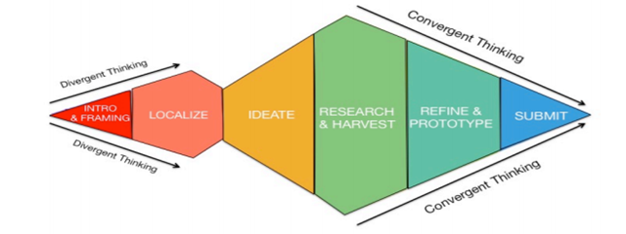

- Lastly, ask participants to relate this to their own experience—have them think of a time when they had to solve a problem. Was the solution always obvious? More often, they will have had to think up with a number of possible solutions, explore and develop a few that seemed most appropriate, and select the best one to refine and apply.
- Explain that Brainstorming is the process through which teams will create ideas to solve their problem. Emphasize that the goal isn’t to create a full or perfect solution; big and small ideas are welcome.
- Explain that Brainstorming focuses on creating as many ideas as possible.
- Finally, emphasize that, later on, there will be steps in the process by which you filter ideas that won’t work, or are infeasible; in this stage, however, concentrate on creativity!
- Defer judgment. You never know where a good idea is going to come from. The key is make everyone feel like they can say the idea on their mind and allow others to build on it.
  - Encourage wild ideas. Wild ideas can often give rise to creative leaps. In thinking about ideas that are wacky or out there we tend to think about what we really want without the constraints of technology or materials.
  - Go for quantity. Aim for as many new ideas as possible. Crank the ideas out quickly and build on the best ones.
  - Record everything! Anything that pops into your head, write it down. One idea per sticky note.
  - Build on the ideas of others. Being positive and building on the ideas of others take some skill. In conversation, we try to use “and” instead of “but.”
  - Stay focused on the topic. Try to keep the discussion on target, otherwise you can diverge beyond the scope of what you're trying to design for.
  - One conversation at a time. Your team is far more likely to build on an idea and make a creative leap if everyone is paying full attention to whoever is sharing a new ideas.
- Each team should follow the brainstorming rules to create as many ideas as they want -- at least 20! You may want to step in to help if there is a very high number of ideas or if the group is struggling to get going.
- When the groups have a good number of ideas, ask them to step back and review their ideas to check if there are any overlaps or repetition - or to see whether new themes are emerging.
- When the groups have finished, ask the groups to connect and combine two or three ideas and try to build more robust ideas.

NO SOLUTIONS BEFORE THIS POINT

As the day is concluded, congratulate the team on the hard work, and encourage them to start thinking of solutions since the next day, the exercises will deal with designing the solution.

Day 2
8:00 – 9:00 | Breakfast
9:00 – 9:30 | Morning exercises and energizers
9:30 - 10:00 | Brainstorming part 2
10:00 – 11:00 | Idea Design
11:00 – 12:15 | Concepting / Modeling
PROTOTYPE PHASE
12:15 – 13:15 | Lunch
13:15 – 13:45 | Choosing what to prototype
13:45 - 14:45 | User Stories
14:45 - 15:15 | Break and energizers
15:15 - 16:15 | Methods of Prototyping
TESTING PHASE
16:15 – 17:15 | Testing and Feedback
17:15 – 18:00 | Incorporating Feedback
18:00 – 18:30 | Wrap up and energizers
18:30 – 19:30 | Dinner
19:30 – 21:00 | Movie evening

MUST - Idea Design

Objective: Participants will have the chance to connect and blend brainstorming techniques to be able to construct more complex ideas that is a leading step towards crafting solutions.
<Time: 60 min>

- Explain that in this session participants will work to give some more shape to their idea(s). Participants will be assessing the feasibility of the idea, developing an understanding of how it will run and estimate the eventual impact.
- Ask participants to select 2-3 ideas (or groups of ideas) from the Brainstorming exercise. They will be completing questions for each of them, as a team.
- Note – ask participants to name each idea so they can distinguish between them when they are talking about them. These names can be as simple as ‘The platform’, ‘ Right to play’, ‘The Pepsi Can Plan’, “Fruit Jam’ or any names that help them remember the idea easily.
- Provide the participants with the following questions that they should ask about each of their ideas. Note - it may be useful in a class in which many can not read or write for the facilitator to ask each question and then pause as the team discusses their answer.
- Suggest to teams that they answer these questions for the idea that they think is best first:
  - Who is it for? Who are we solving the problem for? Who will use this and who will be the people that will find it most valuable?
  - What is it? Describe the idea in detail. What are its main characteristics? Be as descriptive as possible. You might be clear in your mind what your idea is, but it is important to be able to summarise the main aspects of your idea to other people.
  - How would it work? Think about how people will first hear about the idea, how will they realise that it is something they would like to try, how would they start using it, and how would they interact with this in their lives? What value would they see and how would this show up?
  - Who are the stakeholders? Who is involved in the delivery or could be affected by the idea? This is a good opportunity to consider who you might need to work with to deliver the idea, who might be a supplier, and who might indirectly benefit from your idea?
  - What is the benefit of this solution? What difference will users see in their lives and in what area of their lives? If that happens, then will people begin to see a difference in the community as a whole?
  - What is our rating of this idea? Ask the participants to rank their ideas from 1-5 (1 being the lowest and 5 the highest) in regard to 1) how new the idea is, 2) how beneficial it will be, 3) how easy it will be to make it a reality
The reason behind these questions is so that the teams have a much better understanding of the key ideas prior to prototyping them.
MUST - Building a concept

Objective: Participants will visualise their concept and by doing this, see the gaps and connections.
<Time: 1:15 hours>

- Explain that concepting helps to build and connect ideas into a complete solution that helps us achieve our Design Challenge.
- Explain that we'll be using sketching to show the connection between ideas, and visualize what users will actually be doing—be it interacting with a service, or using a product—in a flow, sometimes called the Customer Journey.
- Explain the purpose of the sketching exercise—to translate our ideas into a model—also helps highlight gaps in our thinking.
- Highlight important principles for Concepting:
  - The concept should solve your Design Challenge for the Persona you developed earlier
  - Build on and connect your ideas from the brainstorming and ideas design phase. They don't have to use all of the ideas—only the ones they think should be part of a solution—and they can add or remove ideas as they move forward.
  - Get visual. This is vital – sketches should be a mix of words and pictures. It doesn't matter if you're a terrible artist—use stick figures!—so don't get bogged down in the drawing.
  - Sketches should map the user's use of the product or service. Their Persona should be represented in the model!
- Give the teams 30 minutes to discuss the concept thoroughly and how it connects to the principles of Concepting just discussed.
- Give the team drawing implements and flipchart paper.
- Explain that they will have 45 minutes to sketch out their model. The model should ideally draw on the ideas they identified during the previous sessions and organize them into a logical flow.
- Note: During this phase, it's vital that you use questioning to help advance their models and highlight gaps. Questions like: “How did they find out about your product or service in the first place?” “Where does that service take place, and who delivers the service?” are good places to start. Also, questions that
- highlight disconnects between the concept and the Persona can be helpful: e.g. “How would [Persona] be motivated by this?” “How might your concept reflect [a particular condition of your Persona (e.g. that your persona is out of school, or has limited access to the internet)]?”
- Note: Offer praise and reinforcement focusing on how team members have built on one another's ideas. Tensions can arise in this phase as decisions will be made around which elements to include and which to eliminate. Some tension is understandable; it will be up to you as facilitator to determine what is acceptable and what is debilitating and requires your intervention. If you need to intervene:
  - Emphasize that all parties have a right to speak, and that all parties have a right to be listened to.
- Ask teams how they feel at the close of this process. Energized? Confused? Can they start to see solutions forming? Did they enjoy it?
- Have teams describe the components of their solution in the Project Plan: Proposed Project and Activities
PROTOTYPE PHASE
MUST - Choosing what to prototype
Objective: Participants will understand the purpose of prototyping, identify possible prototypes, and utilize prototyping techniques in order to build and test key elements of their solution, and iterate on their prototypes using the findings of testing.
<Time: 30 minutes>
- Explain that the purpose of Prototyping is to create a basic version of the key elements of a product or service that we can test and learn from. Note the following:
  - Prototype don’t have to be perfect. Don’t get bogged down in the colours, in the specific wording, etc.
  - Prototyping is iterative: we create a thing, test it, learn from it, and then toss it out and build a better version!
  - There are lots of different ways to prototype, but we’re going to focus on four:
    - Role Plays for Interactions
    - Story Boards for Services
    - Paper Prototypes for digital tools, awareness raising materials, or data collection instruments
    - Physical Models for physical, tangible products.
- Have the teams divide a sheet of flipchart paper into four quadrants, and label the quadrants: Interactions, Services, Digital tools/Information, and Physical Products
- Have teams look at their final sketch from the concepting/modelling phase. Look for four things:
  - Interactions: Where do people interact with each other in our model? This might look like the team or user advocating for something, selling a product, or teaching something to someone.
  - Services: Where do we deliver a service? This might look like hosting a sporting event, reviewing documents to provide legal aid, or delivering food aid. This might also look like delivering a training.
  - Digital Tools/Information: Where do we use digital tools, or give information to/get information from people using media? This might be building a website, using a form, or disseminating health information.
  - Physical Products: Where do we use or build a physical product? This might be building a playground, creating a recycling device, or solar powered lights.
- Have the team create a list of things in each of the four categories that they need to prototype by writing one component per sticky note and placing each sticky in the relevant quadrant.
- Choose which component to prototype, focusing on those components that are central to the product or service solution.
Note: If the whole of the solution centres on delivering training, for example, focus on the elements related to the training. It’s also good to prioritize those elements that are user-facing, meaning those elements that the target group will user or interact with.
Teams will likely not be able to prototype all elements in limited time; prioritize the most critical things. Your guidance at this point will be vital for teams; encourage them to stretch, but not over-reach. Prototyping one or two key elements is probably enough.
Note: Every model will almost certainly contain more than one of these elements; some components of the model will comply with all four! Imagine teaching young people to build recycling receptacles: the team will interact with students, deliver a training, rely on training materials and forms, and create a physical product!
- Review with the team the components they've chosen to prototype. Ask them to reflect on why they prioritized this component.
- Offer reinforcement and validation of their decision.

OPTIONAL - User Stories
<Time: 1 hour>
Objective: Participants will be able to utilize the User Stories method to identify and elaborate features of their solutions required by users.
- Have the team start by reviewing their Persona and putting themselves in the perspective of their persona.
- Have the team imagine their Personas interaction with the components the team has prioritized for prototyping.
- Encourage the team to articulate their Persona's needs, etc. in the following format characteristic of User Stories: “As [Persona], I need/want to [need or desire] so that I can [goal or objective]”
  - For example, “As a young girl from a conservative family, I need to be able to discover this training opportunity in a location that I frequent (like a school), so that I can be informed of the opportunity,” or “As a young girl from a conservative family, I need the training to be delivered by a female instructor so that my family will feel comfortable with me attending.”
- Write the User Stories on sticky notes and place them under the sticky on which the corresponding component is written.
- Have the team discuss and work collaboratively on the exercise to develop 5 to 10 User Stories. Post the notecards or sticky notes on the wall; you may want to order them top to bottom by importance, and group related stories.

MUST - Methods of Prototyping
Objective: Participants will be able to identify and deploy appropriate methods for prototyping key components of their solution.
<Time: 1 hour>
- Explain to the team that, for each“category” of component, there are methods that are best suited for prototyping and testing that component.
- Distribute the Prototype Methods sheets to the team.
- Revisit the component categories and their corresponding methods
  - Role Plays for interactions
  - Story Boards for services
  - Paper Prototypes for digital tools, awareness raising materials, or data collection instruments
  - Physical Models for physical, tangible products.
- Ask the team to review the components they've identified and prioritized for prototyping, and to select the Method that corresponds to the “category” of that component.
- Set aside the remaining cards. Let them team know they can revisit them later if they have time to prototype another component of their solution.
- Have the teams work through the Prototype Method exercises for the prioritized component. Encourage teams to refer back to their User Stories to ensure that priority features, needs, and constraints are represented in their prototypes. At the conclusion, teams will have delivered either a role play, story board, paper prototype, or physical model (depending on the nature of the component they've chosen to prototype).
- Time permitting, have teams work through the Prototype Method exercises for other components they've prioritized.
- Ask teams to reflect one what they've built. Does it account for the needs of their Persona? Will it be accessible to him or her? Is it appropriate given the context?
- Ask teams to reflect on how they can discover whether their prototype works. Use questioning to steer them toward the answer: test it with users!

TESTING PHASE

MUST - Testing and Feedback
Objective: Participants will be able to develop and deploy testing and feedback plans to learn from user's experience of their prototypes.
<Time: 45 min>
- Explain that prototypes are just like those rough draft exam answers—we test our prototypes with users, gather their feedback, and use their feedback to make a better version—one that gets a perfect score! Feedback from users helps us learn about how our solutions succeed, and where they fail. They also help us uncover new user needs and requirements.
- Explain that, in order to understand whether our prototype works and what changes might make it work better, it's helpful to build a plan to gather feedback through a mix of methods.
- Explain that, similar to the User Research participants conducted in the preparation phase, we'll plan to use a mix of observation and interviews to gather feedback on our prototype.
- Provide participants with the Feedback Template.
- Have the team reflect on what questions they may have about how users will engage with their prototype. Is there anything they worry might not work? Anything they worry users won't understand? Have the team work together to identify three questions they want to ask during an interview with users.
- Note: you may want to employ Brainstorming Principles if teams are having trouble coming up with questions.
- Review with the team the Interview Principles from the preparation phase. Reinforce the importance of observing and recording the user's interaction with their prototype.
- Lastly, have the team identify users with whom to test their prototype. Users should ideally represent members of their target group and share characteristics with their Persona; if appropriate, encourage the team to ask participants from other teams to test their prototype. If they are unable to recruit an appropriate user, you as mentor can role play as a member of their target group / Persona.
- Have teams deploy their Prototype with their user, and have each team member observe and record the user's experience.
- Have teams complete the interview questions.
- If time permits, test with one or two more users.
- Close by offering reinforcement and encouragement to teams: remember, this is the first time they've tried their solution with another party.
- Highlight to teams that, under usual circumstances, designers would test their prototype with many people, and reinforce that user testing is commonly done with a member of the target group.
- Have teams reflect: did their solution work as anticipated? In what ways was it successful? It what ways did it fail?

MUST - Incorporating Feedback
Objective: Participants will be able to synthesize and utilize feedback from user testing to develop new and/or refined user requirements, and incorporate feedback into an improved prototype.
<Time: 45 min>
- Explain that, after you've tested your prototypes, you'll have lots of observations and feedback from users. We'll work on understanding the feedback so that we can incorporate what we've learned into a new design (and get that perfect test score!)
- Revisit the idea of iteration: that we build, test, and use the finding to build a better version. Reinforce that challenges aren't an indication of failure, but rather a step in an iterative process—one that the best companies in the world go through.
- Note: If it is relevant to your team, you might draw comparisons to Facebook or Instagram—have the team reflect on the many changes and new features that have been added or removed over the development of those applications based on user feedback. No one would call either a failure!
- Have the team individually review their feedback and observations, and write significant findings and observations on sticky notes.
- Using a similar process to the Brainstorm method, have the team place stickies on the wall and similar observations and findings.
- Discuss.
  - Ask the team: Based on the user feedback, what went well? What elements was difficult for your user? Not useful? Unclear? Did they meet the criteria identified in your User Stories?
- Have the team prioritize areas for improvement. Translate new requirements to User Stories, and add them to the backlog.
- Note: If you think it would be valuable, employ the brainstorm process to help the team develop alternatives to their current prototype. You may also want to revisit the Concept if things feel really off the rails.

Day 3
09:00 – 10:00 | Breakfast
10:00 – 10:30 | Morning exercises and energizers
MAKING IT REAL
10:30 – 11:15 | Baking the cake
11:15 – 12:00 | What the future holds
12:00 – 13:00 | Pitching preparation
13:00 – 15:00 | Lunch and continuation of pitching preparation
15:00 – 17:00 | Projects pitches
17:00 – 17:30 | Positive Reflections Exercise
17:30 – 18:00 | Selected solutions announced
18:00 | Departure
MAKING IT REAL
MUST - Baking the Cake
Objective: Participants will be able to analyze their models and identify and define resource requirements.
<Time: 45 minutes>
- Explain that despite the sophistication of the work they’ve done, determining the resources they need to build and deliver their solution isn’t all that different than determining the resources one would need to bake a cake - use a different example if more appropriate.
- Have the teams imagine what would we need to be able to make and sell a cake. Ask them what things they will need to bake that cake. The initial responses will likely be ingredients. Explain that ingredients are resources or inputs to our cake.
  - Label one quadrant of a large piece of paper “Supplies and Materials”
  - Note: depending on the team’s capacities, you might note that these are variable resources – while we need a certain amount of each ingredient for one cake, if we make 10 cakes, we will need 10 pieces or 10 times the amount of that ingredient.
  - Ask: what about the tools to make that cake? Responses will likely be utensils, a bowl, a mixer – even the over. Explain that this equipment is an input as well. Go ahead and label another quadrant of the large piece of paper “Equipment”
  - Note: depending on the team’s capacities, you might note that these are fixed resources – if I want to make 1 cake, I need 1 mixer, whereas if I want to make 10 cakes, I will still need only 1 mixer.
  - Ask: what about the person who does the work? Another input – a human resource. Label the third quadrant “Human Resources”
  - Ask: finally, what about the building there you will do the baking? Transporting the ingredients to the baking site, and the cake to its final location? Advertising cakes for sale? These are all your final inputs. Label the final quadrant “Support”.
- Have teams inspect their model and prototype in order to start identifying the needed resources to produce and deliver their solution.
- Ask: where do you require supplied and materials? This could be anything from paper and pens to binders for documents to ingredients for a cooking course
- Have teams write their responses on sticky notes and place the stickies in the relevant quadrants. Use questioning to highlight supply and material inputs the team may not have identified on their own. The following are some prompting questions that they can use to come up with the missing “ingredients”.
  - Where do I need equipment?
  - Where do I need human resources to accomplish a task and what skills must they have?
  - Where and how must I support my activities?
- Have the teams complete the analysis of their prototype and concept and identify resource needs, placing each sticky in the relevant quadrant
- Finally, have the team identify which resources they have already and which resources they will need to secure.
- Explain to the team that a budget is a little more than a plan that identifies and defined inputs and their costs over a period of time.
- Ask them to estimate the cost of these items. They are unlikely to know the amount for all of these items, so please be ready to provide them with an estimate. Then ask them to add it up for a total cost and provide help where required.
- Have the team transfer their resource needs to the Project Plan: Budget and Budget Narrative.

MUST - What the future holds
Objectives: Participants will have the chance to start learning about sustainability mechanisms and the operationalization of their projects beyond the support period.
<Time: 45 minutes>
Introduction
- Ask teams to think about a time they have needed resources to achieve a goal. have them provide concrete examples (e.g. I wanted to buy a phone)
- Ask: what were some of those strategies to secure those resources (examples could include: “I asked if I could have my sibling’s old phone”, “I asked my parents for money to buy the phone” etc.)
- Explain to the team that these strategies: generating revenue, securing funding or resource contributions, are all valid strategies for ensuring the financial sustainability of their project - the project’s ability to continue even after the initial funding runs out, or the ability to continue the impact of the project even after the project is over.
- Note to teams that sustainability is considered to be the hallmark of a good intervention, and that donors will want to know that their investment will have life even after their money runs out.
- Have the team reflect on the inputs they still need to secure.
- Note to teams that paying for inputs is one way of securing them; but there will the money come from?
- Have the team review their model, their stakeholder map, and their list of inputs.
- Ask the team if any party within their Stakeholder map is willing to pay for their service outright?
- Explain that stakeholders who share their vision and have resources might be interested in supporting your cause, product, or service. Others, like institutions, might adopt the project. Have the team discuss, analyze stakeholders, and determine if any of them share the team’s vision. Using sticky notes, write down potential donors or institutions
- Ask the team if there are components of the model that they might charge a fee for. Explain that in most cases, charging target beneficiaries for a fee might not be appropriate, however, stakeholders such as parents, might be willing to pay a fee on behalf of the beneficiary. Using sticky notes, write down potential stakeholders who might be willing to pay for part of the model.
- Ask the team to review their outstanding inputs and their stakeholder map. Ask the team who might consider providing inputs at no cost (called, an in-kind contribution). for example, an institution might make spaces available at no cost, a local NGO might provide free technical assistance; target group members might volunteer etc. Using sticky notes, write down stakeholders who might provide in-kind support, next to the relevant resources.
- Lastly, ask the team if there are components of the model that can continue without inputs. for example, training recipients can become trainers themselves afterwards, this way eliminating human resource necessities. Using sticky notes, write down ideas for sustaining the impact of the project.
- Reinforce that it is alright if the teams don’t have all the answers for every resource - that’s what funds are for.
- Have the teams summarize their results in Project Plan.

MUST - Pitching preparation
Objective: Participants will learn how to craft a concise and effective pitch to get the idea of their project across.
<Time:1 hour>
- Now that the students are finalizing their prototypes they must work on how they will be presenting them to the judging panel.
- Ask the teams to take 5 minutes to think of the entire process they have gone through and make a mental summary of what this experience has consisted of.
- Explain to the team that pitching is not simply about remembering what to say, it is also important to convey authenticity. This enables the audience to trust gain trust in the pitch. It is useful for young people to try to be themselves as much as possible when pitching, whilst being clear, concise, and convincing!
- Highlight the following principles to help develop and make a good pitch.
- What you present - your pitch needs to address the following questions:
  - Articulate your idea in one sentence encompassing your unique selling point (what will make people select your product or service over another one). This is sort of like a Twitter pitch. For example, Trunk Club: good-looking men’s clothing with personal online service for men who need clothes but hate shopping. Cafe Yumm: Really healthy really tasty fast food with slow food values in Oregon. Franchisor too. Mini-Cooper-S: bite-sized transportation for one or two with a kicker: unbelievably fun to drive. Java Juice: easily transportable high-quality great-tasting condensed coffee for coffee lovers who travel or backpack. Just add hot water.
  - What is the problem you are trying to solve and why is your solution the best?
  - Who are you trying to help?
  - Who are you presenting to? What might be important to them?
  - How will existing products, services and people already working and living in this area help you?
- How you present – the style and tone of what you present
  - Think about the roles that each of the team members play in the final pitch?
  - Make sure to introduce each team member and their 'super power' or key strengths and skills and / or passions.
  - Be sure to invite questions and don't get defensive.
  - Ensure you have picked a pitching style that everyone is comfortable with.
  - How are you showcasing your prototype?
- And finally, do not forget:
  - Make the pitch concise – at this stage listeners need the key aspects, not every detail.
  - Most importantly of all - have fun!
- Ask the teams to prepare their pitch and remind them this is a rehearsal and a chance to try things. The most important thing at this stage is to work out a style and coordination of the pitch that suits the participants.
- Make it clear that each team will have a time limit to deliver their pitch, in this case 5 minutes for the pitch, and 5 minutes for the jury to be able to ask questions.

MUST - Pitching
<Time: 2 hours>
- Tell everyone that it is now time to pitch!
- Ask the teams to try to watch and listen closely to the other pitches.
- Each team gives their pitch in front of the jury and to the rest of the teams. When they finish, the participants should applaud and celebrate the pitch. The team cannot sit down until the last clap has been heard. This is very important to ensure that everyone feels recognized, valued, and to practice gratitude.

OPTIONAL - Positive Reflections
<Time: 30 minutes>
- While the jury is deliberating on the pitches, one good positive reflection exercise to do with the entire group participants is the Three Good Things.
- Ask everyone, including facilitators, to sit in a circle and take a stack of sticky notes with them
- Ask all to write three good things that happened to them each day for the entire length of the bootcamp
- Have a group reflection on why each good thing happened and how they can cause it to happen more
- If participants are reluctant to start the conversation, have some of the facilitators start.
- End the conversation with positive notes and thoughts about the coming days and months to set a positive tone in preparation for the announcement of projects moving to the next phase.

4.6 Judging and Announcing the Winners

Judging the Bootcamp

Generation Unlimited is designed to empower young people of all genders, nationalities, backgrounds, and abilities to achieve their potential and create solutions that will support the goals of Generation Unlimited. The goal (through judging) is to identify the young people with the greatest potential to create community changing projects; the youth that have the greatest passion and ability to learn and adapt to the difficulties that they will face.

These young people may not be the ones with the greatest solution today, but are those that will continually work to improve themselves and their teams to accomplish great things in the future. Our judging criteria are focused on advancing these types of youth.

It is important that judges understand human rights, equity, equality and the values and focus of Generation Unlimited and the Youth Challenge. You should ensure they receive a full briefing / training session to include background on Generation Unlimited and the Youth Challenge, child rights, diversity and gender sensitivity.

It is very important to share the judging criteria and process at the very start of the bootcamp with all participating youth.

The Process
The recommended approach for selecting judges is to have at least 3 people (odd number) divided by organizing partner, challenge topic expert, and other expert from the private, public or CSO sectors or academia. This is a good opportunity to engage stakeholders who could be supportive of the Youth Challenge and youth-led projects. There will also be a crowd “judge” (aka the collective views of all young people participating in the Youth Challenge). This brings immediate youth feedback on the proposed solutions. It is important to have a diverse judging board that can provide objective feedback and a balanced result. The final “judge” will be the vote of the facilitators (or all of those who worked closely with the groups). The facilitators are one of the best resources to understand the teams and their motivation better. Due to the fact that COs may choose to add more partner judges to the process, we advise that the overall proportion of the different judging should be held stable to maintain consistency. In the process that is described below, the proportion is 60% of the score from judges, 15% from facilitators/mentors, and 25% from crowdvote.The table below gives an example set of judges for the Generation Unlimited bootcamp.

Judge # | Organization | Expertise
1 | One of the organizing partners (UNICEF, UNDP, Plan International, Scouts) | Development (e.g. Representative / Deputy Representation, ADAP, Innovation, Education or Child Protection)
2 | Challenge Topic Expert | Must have in-depth knowledge about the challenge topic
3 | Private Sector (or must be a successful entrepreneur) | Human Centered Design, Entrepreneurship, small organization development  Must understand how to build successful enterprises and projects
4 | Crowd Vote | The participants get to vote too!
5 | Facilitators’ Vote | Facilitators’ contribute around the motivation the teams demonstrated during the bootcamp

The judging process for the Generation Unlimited bootcamp starts with a showcase from each youth team where they present their progress towards a solution based on what they have done over the course of the bootcamp. The recommended style for this showcase is that of a presentation/ exhibition. In this method, each team will set up a small, mobile booth in the venue where they display their work, including any prototypes, from the bootcamp. The team then will move the mobile booth in front of the judges and the teams give a strict 5 minute presentation, with 5 minutes for Q&A. In the meantime, the rest of the youth groups will be sitting behind the judges and listening carefully. The showcase should be attended by all participants, mentors, and volunteers from the bootcamp. Outside visitors are encouraged, especially those who may help with the mentorship/additional training, but not necessary. The organizing team should make sure that the environment is quiet and conducive to proper presentations.

Bootcamp Presentation Rules
Rule | Rationale
5&5 - Total 10m for the presentation. | Maintain fairness across all teams. Strict enforcement of the timing rules is highly encouraged.  Exception: Deaf teams are provided with 2 extra minutes in the Q&A section in order to compensate for extra time needed to translate.
The order of the presentations is random. Be ready! | Each team needs to be ready before the presentations begin. By randomizing the order they will not know when they have to go. By preparing early, they will be able to listen to other teams and cheer them on!
Tell your story, show your progress. | This should not be seen as just a pitch for funding; instead seek to inspire the audience to understand your problem and demonstrate how your solution will make a real difference. You can answer questions about cost later!

Judges Scoring

There are 4 specific criteria for the judges to consider in their scoring: Overall performance, Relevance, Impact, Sustainability. Each is scored between 1 and 5 based on the rubric linked below. The judges should score each team before moving on to the next presentation and the scores should be made independently. The table below gives a description for each criteria.

Criteria | Points | Description
Pitch Performance | 1 - 5 | The team’s pitch was clear, concise and convincing. They handled Q&A well.
Impact | 1 - 5 | Accurately defined an authentic need for the people who are experiencing the problem. Indicators/arguments are based on valid assumptions from research
Feasibility | 1 - 5 | The team has articulately and clearly presented a solution that is realistic based on their field work.
Innovation | 1 - 5 | Is the idea presented innovative (as opposed to an existing solution)?
→ Total | 5-20 | Total Max score = 20 points from each judge. 60 points in total (for 3 Judges). Maximum of 60% of overall score.

Following the final presentation by the teams, the judges should be sequestered to a separate room for a debate around their scores and choices. An arbiter from the Generation Unlimited programme (like the staff in charge of the program) should compile the scores into a single sheet. Any major differences in opinion, such as one judge scoring a 1 when the others score a 5, should be discussed and judging rationale presented. No changes should be made to the independent scoring unless there was a misunderstanding of the team or their context. Finally the arbiter should add the scores and create a ranking from 1-10 of the teams from the judges choice. A template score sheet has been made for you, find it here.
While the judges are sequestered, the facilitator in the bootcamp should provide the youth participants with the chance to crowd vote. This is also a time when you can ask participants to complete the skills assessment questionnaire.

Crowd vote

The recommendation for crowd voting is to give each youth 3 stickers, and ask them to put them on the teams they think did the best job throughout the bootcamp to develop their ideas, or that they think deserve the chance to move forward. There is only 1 rule, you cannot vote for your own team. If they want to put all 3 stickers onto one team, that’s ok.
When all stickers have been placed on the team boards, an organizer should count each teams’ total and take the result into the judges. The team with the most stickers receives 25 points, the next 24, and the next 23 and so on until all teams have been awarded with the crowd vote. This scoring method provides two important benefits to the judging process. The first is that it gives accountability to the young people in contributing to the result. The second is that it provides a natural tie-breaker to any judge scoring.

Facilitators / mentor’s vote

There is an overall teamwork score, which should be completed by the mentors or facilitators working directly with each team during the bootcamp. They will have unique insight into how the team worked together to overcome challenges and their motivation to continue to develop their idea.

Mentors are asked to rate each of the below from 1 to 3 (this score will be included as 15% of the to the team’s overall score). The mentors should fill in the form (ideally an online form) to submit their scores before the pitching begins.

Criteria | Points | Description
Team’s motivation | 1 - 3 | Did the team demonstrate motivation to identify real community problems and solutions?  Were they motivated to work together to overcome challenges?
Team’s likelihood to remain together till the end of the Youth Challenge | 1 - 3 | Did the team develop a strong sense of shared identity?  Does the team seem motivated and keen to continue to work together?
Cohesion of the team | 1 - 3 | Did the team work effectively together?  Were they able to overcome differences in a constructive manner?
Team’s tendency to take initiative | 1 - 3 | Did the team take initiative or were they waiting for instruction from their facilitator / mentor?
Team’s understanding of Design Thinking and the process | 1 - 3 | Did the team understand the exercises they were doing and how they added value? Do you think they will be able to continue to use this learning? (for example, continuing to engage with potential users and stakeholders in iterating their prototype)
→ Total | 5-15 | Total Max score = 15  If a different scoring mechanism is used, it should account for 15% of the total overall score

Combining the scores

The judges score should be a maximum of 60 points if you have 3 judges. If you have more than 3 judges this should be weighted to be 60% of the total. The mentors score should be a maximum of 15 points and the crowd vote should be a maximum of 25 points.
All three scores are combined and each team receives a total out of a total of 100 points for the final list. As a point of comparison, the judges ranking and the crowd vote ranking can be compared to see how different they are. When the final ranking is agreed upon by the judges and certified by the program organizers, the facilitator can take the list and announce the 5 teams that will receive seed funding.
Important note on how to speak about progression in the challenge

Each team has put in a tremendous amount of effort and thought into their projects. Our selection of teams is not always based on the best solution, but the best combination of factors that will advance teams that are ready to take on greater challenges. It is important that we use language that recognizes that intention. Instead of announcing the “winners”, you should consider announcing the 5 teams that have advanced, or that have demonstrated the capacity to take on the challenges of the next phase of the challenge. You should also use this as an opportunity to reflect on the progress that all young people have made, the skills they have developed and the opportunity to continue on this journey (whether they receive seed funding or not).

Scoring Rubric for judges to use in the Generation Unlimited Youth Challenge

The way the rubric works is if the statement in score box 1 can be considered true, then the team is awarded 1 point and you move on to the next box. If the next score box is not true, then they are awarded only 1 point for that dimension. If it is true, and all statements are true (1-5) then award them 5 points. As you work up the score boxes, remember that all previous statements must remain true (if you are scoring for 5 points, then the statement in score box 1 and 3 must remain true). If the reality is somewhere in between you can score 2 or 4.
Score  1  Point | Score  3  Point | Score  5  Point

Scoring Criteria |  |  | Dimension
Team hasn’t presented the problem very clearly. or Team showed a good understanding of the core of the problem, but there is a weak connection between the problem and solution. | The idea address a real, tangible problem that a considerable number of people experience. The solution has promise of creating real, measurable impact. | The team has shown an excellent connection between their problem and the solution with a clear path towards measurable impact. | Impact  Is this problem widely experienced by many people? Does the proposed solution address a real (observable) problem? Does this idea have potential to positively impact the lives of those affected?
It isn’t clear whether it will be feasible to implement the idea due to e.g. technology issues, stakeholders that would need to be on board. | The team has interacted with potential customers and stakeholders and has an understanding of the parameters of their idea and how to overcome potential barriers to implementation. | The preliminary evidence shows no major issues with its feasibility. The team presents how the idea will be sustainable in the long term. | Feasibility  Is this idea realistic? Do critical aspects of this project rely on stakeholders beyond the team's sphere of influence? (Major technology, market or authority dependencies)?
The team has presented an idea that is a local adaptation of a similar idea. | The idea shows some innovation by changing/adding to an existing product/service or by using an existing product or service in a different way. | The team presents an idea that is completely new. | Innovation  How innovative is the idea?
The team has put little effort into the presentation and prototypes. Their pitch was slightly confusing. | The team has put moderate effort into the presentation and prototypes. Their pitch was somewhat clear. | The team has put considerable effort into the presentation and prototypes. Both were memorable. Their pitch was clear, concise and convincing. | Pitch Performance  The team was clear, concise and convincing. They handled Q&A well.

Judging Intention: The program is focused on developing PEOPLE as much as PROJECTS. Please consider that we are looking for the young people with the greatest potential to create community changing projects – the youth that have the greatest passion and ability to learn and adapt to the difficulties of Social Entrepreneurship. Look for skills and qualities in the youth and their projects that will help them achieve great things in their future.

Judging Resources:
- Judge Score Cards (paper)
- Mentor Google Form Template (Note that this link will require you to make a copy for your own CO and adapt the content). It allows you to send the form to mentors and they can respond before the pitching begins.
- Google Spreadsheet for collating scores

Appendixes

Appendix 4.3.1 Stakeholder Mapping
- On a whiteboard or flipchart paper, recreate the chart on the right. You’ll use this to organize your thinking.
- Start by asking who directly experiences the problem you’ve identified. Try to be as specific as possible. Is it people of a specific age? People who live in a specific area? People who belong to a specific group (like high school students, or members of a specific community)? This is your target group (also called beneficiaries or rights-holders)—you will prioritize their needs when designing your solution. Write these down on sticky notes and lay them out like in the graph in order to visualize your target group.
- Ask who is indirectly impacted by the problem you’ve identified? This might include family members, peers, and other people or groups associated with your target group, or that that indirectly experience effects of the problem. These are people who may be motivated to support or otherwise participate in your solution. Write these down on sticky notes and lay them out in order to visualize your Indirect Beneficiaries.
- Think about other people or groups who are connected to the problem. Are their people, groups, or institutions that contribute to the problem? Groups that are already trying to solve the problem? Again, try to be specific—there’s a big difference between “the government” and “the Director of the Municipal Department of Youth”. Write these down on sticky notes and lay them out to visualize your Other Stakeholders.
- Try to group your sticky notes by stakeholders that have things in common. For example, you might make a group of NGOs working in your community to solves the problem, or companies in a certain area or delivering a similar service. There’s no right way; make groups that make sense and feel useful.
- Lastly, try to note or visualize how stakeholders are connected to the problem. You might use different colors or icons for supporters and allies, skeptics, service providers, responsible parties, or impacted groups.
Once you’ve completed your Stakeholder Map, you’re ready to move on to User Research, where you’ll learn more about the needs, behaviours, and motivations of your stakeholders.



Appendix 4.3.2 Needs Finding Matrix

 | OBSERVE | ENGAGE | IMMERSE
Who/Where/What
Observation
Insight
Who/Where/What
Observation
Insight
Who/Where/What
Observation
Insight

Appendix 4.3.3 Guidelines for Interviewing
- Form your stakeholder map, identify which groups are most closely connected to your problem and write a name for each group in the boxes below. This should certainly include your target group, and may also include indirect beneficiaries or key stakeholders.
- From your stakeholder map, identify the key characteristics that define each stakeholder group. These will be things like age, gender, geographic location, occupation, educational status, ethnicity, relationship with the problem. List those characteristics along with the group name in the big boxes below.
- Identify and recruit specific people that represent these groups. We suggest conducting at least 5 interviews total; three with target group members, and two with other stakeholder groups. (We’ve included four groups below, just in case you want to research another stakeholder group.) To recruit:
- List people you already know that fit in the stakeholder groups.
- If you don’t know a person who fits a particular stakeholder group, list places you might find such a person (e.g. a hospital) and start there!
- It can be helpful to use social networks to find people to interview.
- When it’s time to schedule the interview, contact the person and Introduce yourself, and explain what you’re doing (e.g. “Hi, I’m [your name]. I was recently accepted to Generation Unlimited Youth Challenge,, a competition to solve community challenges in partnership with UNICEF. I’m conducting research into [your problem]; might I have 20 minutes of your time to interview you on this issue?”
- If potential interviewees have questions, you can put them in contact with the Innovations Lab Team.

1. Develop 3-5 interview questions. When developing questions, consider:
- Questions should help us explore our assumptions; consider asking about things you think you already know about your problem (like causes, or even stakeholders) to get a more complete understanding from the user’s perspective.
- Questions should help us uncover needs, behaviours and actions, and motivations.
- The goal is to have users tell us a story. Every question is a starting point; you will use follow up questions to go deeper.
- Try not to ask leading questions. A leading question encourages interviewees to give a certain kind of answer (i.e. don’t ask “How angry were you?” Instead ask “How did that make you feel?”)
- Avoid yes/no questions—they don’t go anywhere!
- Questions should start broad and concrete (e.g. “Have you ever had a problem with [your problem]?”) and move to specific and abstract (e.g. “What motivated you to make that choice?”

2. Write your questions in the blanks on the right.

3. It’s good to ask different stakeholder groups questions tailored for their situation, so do the same (on a separate sheet of paper) for each stakeholder group with which you plan to conduct interviews. Try to ask members of the same stakeholder group the same questions.

Make sure to bring your questions when you conduct your interviews!

Appendix 4.5.1 Project Plan Template

Problem Statement and Situation Analysis
(To be completed after teams have done the Problem Tree and Five Whys)

Target Group and Stakeholders
(To be completed after completing Target Group and Stakeholders)

Impact Statement
(To be completed after Impact Statement)

Proposed Project and Activities
(To be completed after Concepting/Modelling)

Budget Narrative
(To be completed during after Inputs / Baking the Cake)

Sustainability

Appendix 4.5.2 Problem Tree

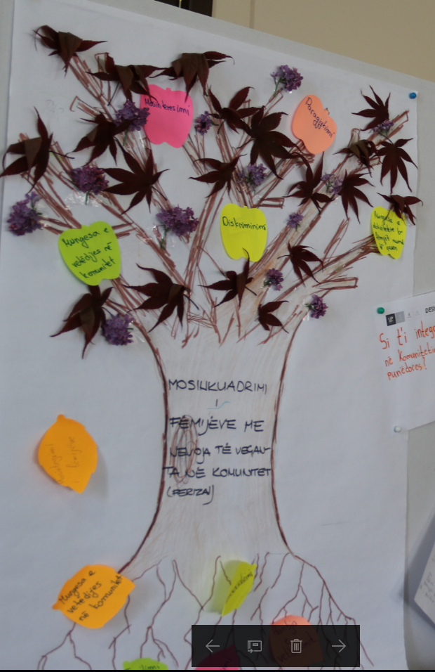

Appendix 4.5.3 Persona Template

 | ____________________________________  Name Surname | Persona Template
 | ____________________________________  ____________________________________  Quote | Persona Template

_____________________________________________  Name | _____________________________________________  Location
_____________________________________________  Occupation/Student Status | ____________________  Age | ____________________  Gender
_____________________________________________________________________________________________
Other Relevant Demographic Information

PROFILE AND BEHAVIOURS

MOTIVATIONS

FRUSTRATIONS

GOALS

Appendix 4.5.4 Design Challenge Template

END STATE | IMPACT STATEMENT

Appendix 4.5.5 Role Play Card
We’ll use role play – a sort of small skit or play – to prototype interactions between people.

From IDEO: “A Role Play is a type of prototype that is not only pretty easy to build, but can also help you get an idea, experience, or product in front of the people you’re designing for quickly. You’d be smart to test out the role play on your design team first. You may learn a lot by trying on the roles of the people in your small skit before you even get out of the office.”

You’ll need:
- Paper and something to write with or a laptop (to outline parts of the interaction) •Found items for costumes and/or props
- A camera or camcorder (a cell phone will do) to record the interaction

To prepare your role play:
- Take a look at your model to determine what needs to happen during your interaction. What is the purpose and/or goal of the interaction? Are you gathering information? Delivering a message? Note this down.
- Determine who needs to be represented in your Role Play and assign the necessary roles to your team members.
- Keeping in mind the purpose of the interaction, create an outline of the key parts of the interaction. For example, if you’re conducting a survey, you’ll need to introduce yourself and the issue, ask questions and gather information, etc. Remember: you can only prototype your side of the interaction; users (or whomever is playing the role of the user) will respond to your prompting based on their own motivations, behaviours, and capacities—not based on a script you prepare!
- It may feel silly, but costumes and props can be highly effective tools in bringing your Role Play to life. Don’t spend a long time gathering them – prototypes are quick tools! –but consider using props if there are relevant physical elements to the interaction (for example: a clipboard and a pen for filling out a survey; a uniform for identifying a service provider).

Later on:
- In the next module, you’ll create a plan to help you observe and gather feedback. Consider including the following questions in your plan:
- What questions did the user have?
- Where did things go smoothly? Awkwardly? How did they receive your information – were they interested and welcoming? Did they find it irrelevant?
- What other resources would you need to improve the interaction? What advanced preparation?
- When it’s time to test your prototype, consider using a cell phone to record the interaction so you can analyze it later.
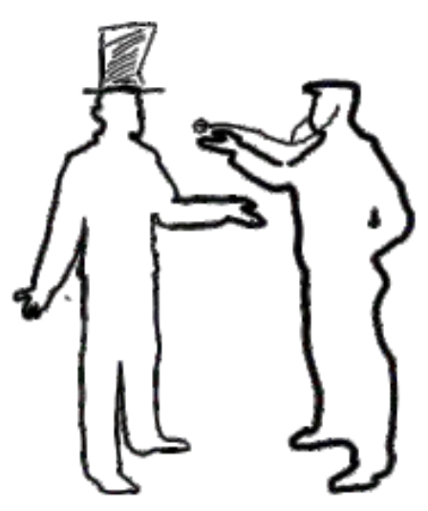

Appendix 4.5.6 Story Board Card

If you’re delivering a service, storyboard is the method for you!
From IDEO: “You don’t need to be a great artist to create a great Storyboard. By visually plotting out elements of your product or service, you can learn a lot about your idea. Not only will this method help you rene what your idea is, it can also reveal who will use it, where, and how. Like all prototypes, the idea here is to make something really rough as a way to help you think the idea through. It’s amazing what putting pen to paper can reveal.”
At the right is an excellent example of a storyboard focusing on surgical services from Service Design Tools.org

You’ll need: Flipchart paper, Drawing tools

To prepare your story board:
- Unlike in the Concepting/Modeling module, Story Boards are used to map a small, specific part of your model. Story Boards should be more specific, and try to map out every step of that component.
- For example, if we’re modelling a training, we may want to storyboard user’s discovering the training (to highlight how they nd out, and how they decide to join), how they get to the training location and where they training takes place, how they are introduced to the material (to highlight who is leading the trainings, and what resources they’ll require), the steps of the training, how they are assessed, and what they do when they’re done.
- Use ipchart paper to create a series of comic book-style frames for your drawing. This will help you spotlight key moments and build a short narrative.
- Think about what is critical to represent in each frame—who should be present? What are they doing? What resources are they using? Where are they?
- Don’t get hung up on your drawing abilities. It’s more important that it helps you fully think through your concept than create something that looks beautiful.
- Short text to accompany and explain the action in each frame is helpful.

Later on:
- In the next module, you’ll create a plan to help you observe and gather feedback. Consider including the following questions in your plan:
- Where are the gaps in your story board? Do characters magically show up in a new location, or have a skill they didn’t have before?
- Where are things unclear?
- When it’s time to test your prototype, walk users through the storyboard.

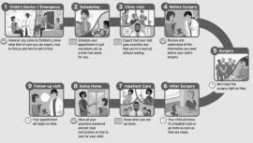 | 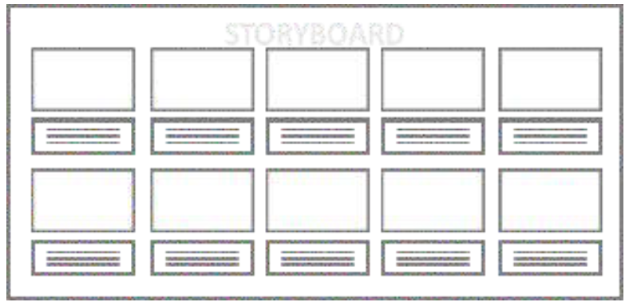

Appendix 4.5.7 Paper Prototypes Card
Paper Prototyping and Mockups let us test designs that would otherwise require technical expertise and timetobuild.

They’reparticularlyappropriatefordigitaltools–likewebsitesandappsorgames–andcan also be used to model data collection instruments (like surveys and forms), or even informational tools (like brochures or lesson materials). They’re particularly useful to convey ideas without wasting time on designing and building actual working digital products, and to test usability.

You’ll need: Flip chart paper and/or printer or construction paper, Drawing tools, Scissors

To prepare your paper prototype:
- Create one mockup for each page or screen of their product. Which users will use it – will they access it on a laptop? Cut paper to the dimensions of a laptop screen. A mobile phone? Do the same. A brochure? Fold your paper as appropriate.
- Focus less on visual elements (like pictures) or even text, but focus heavily on those parts of the product that users will interact with. Are there links? Is there a form? Buttons? A menu? Is it clear what each elements will do? What happens when I click? Refer back to your user stories to ensure you have accounted for key features and functions.
- Cut out elements that will change when the user interacts with them (for example, when the user clicks to expand a menu).
- Create one mockup perscreen/page. Is there a homepage? Prototype all of the elements of the page. Do I go to another page to login? Etc.

Later on:
- In the next module, you’ll create a plan to help you observe and gather feedback. Consider including the following questions in your plan:
- Where are the gaps in your application? Are all of the necessary features and functions present?
- Were users able to discover and utilize features without your guidance? Where can the purpose and function be made more clear?
- What other functionality did users request?
- When it’s time to test your prototype, users can use their nger as the mouse – when they click on an element (again, like a menu) replace it with the expanded menu; when they click on a link, have them move to another screen!
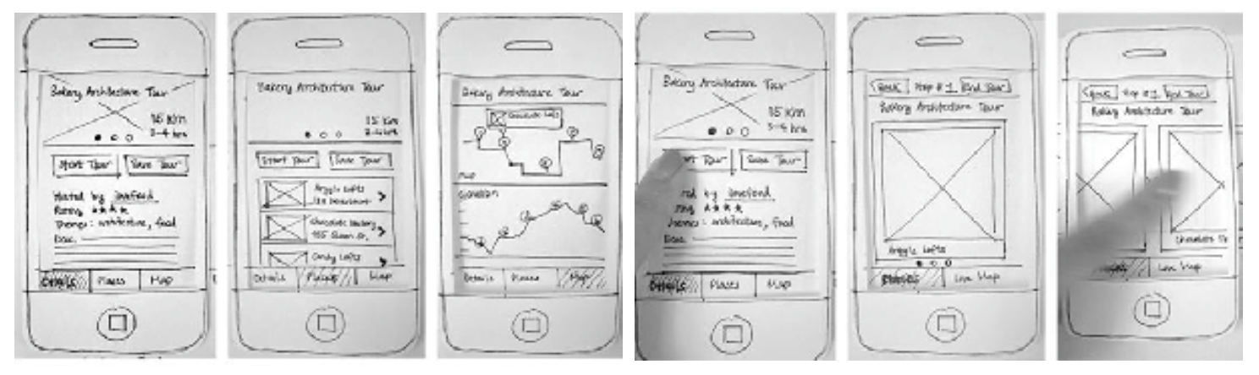

Appendix 4.5.8 Physical Model Card
Models are physical prototypes that let us explore the functionality of a product, and users’ interactions with it. Models can be built with found materials – nothing fancy necessary! The product below is a model of a new recycling receptacle, built of tape and cardboard.

You’ll need: Paper and drawing utensils to draw a mockup; Found materials to build the model

To prepare your model:
- Determine the functionality of their product—what is the purpose of the object, and what is the most essential thing it must do? Your concept/model should help make this clear.
- Similarly to the concepting/modelling module, individually, each member of the team should sketch a version of the product that will accomplish that goal. Come together and discuss the product sketches (remember your Brainstorming Principles). How does it work? What materials are necessary?
- Discuss, and work together to create one nal sketch of the model.
- Break down the materials necessary to construct the product. Substitute hard to nd materials with materials you can nd in their immediate surroundings.
- Start building! Because there are no directions, mistakes will be made, and you may nd this to be a stop and start process. Note down the successful steps you take and important notes (dimensions, for example) to begin to dene the production process. You can revisit the process at a later stage to increase its efciency; for now, it’s enough to be able to reproduce the product.

Later on:

In the next module, you’ll create a plan to help you observe and gather feedback. Consider including the following questions in your plan:
- Was the purpose of the model immediately clear to the user?
- Were users able to discover and utilize features without your guidance? Where can the purpose and function be made more clear?
- Is the object accessible to users?
- Did the model meet users needs? What if any changes did they recommend?
- When it’s time to test your prototype, concentrate on observing users’ interaction with your product – you’ll learn a lot by listening.
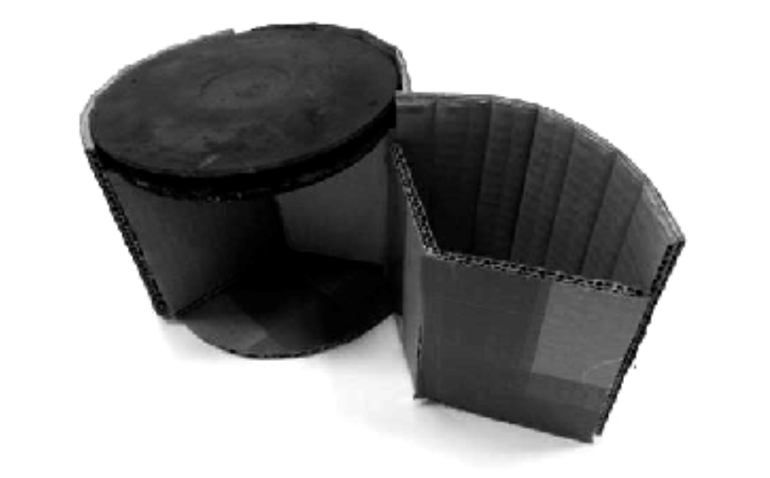

Appendix 4.5.9 Feedback Template

Interviewee Name | Prototype
______________________________________________  (leave blank if the interviewee wishes to remain anonymous) | ______________________________________________

OBSERVATIONS/DESCRIPTION OF INTERVIEWEE (e.g. age, gender, occupation, etc. as relevant)

LOCATION AND OBSERVATIONS ABOUT THE LOCATION

QUESTION 1 RESPONSE

QUESTION 2 RESPONSE

QUESTION 3 RESPONSE

OBSERVATION

Appendix 4.5.10 Participant Worksheet: Pitch Preparation, Pitch Perfect
PITCHING
WHAT ARE YOU PRESENTING
Articulate your idea in one sentence encompassing your unique selling point (what will make people select your product or service over another one?)

What is the problem you are trying to solve and why is your solution the best?

Who are you trying to help?

Who are you presenting to? What might be important to them?

How will existing products, services and people already working and living in this area of activity help you?

HOW YOU PRESENT
What are the roles that each of the team members will play in the final pitch?

Make sure to introduce each team member and their 'super power' or key strengths and skills and / or passions.

Be sure to invite questions and don't get defensive.

Ensure you have picked a pitching style that everyone is comfortable with.

How are you showcasing your prototype?

Before each of the tools laid out in this Facilitation Guide, there is a note on whether the tool is mandatory for the implementation of the youth challenge or whether it is optional. More detailed discussions around how to contextualize the Youth Challenge based on the parameters of the implementation context should be discussed directly with the global Youth Challenge team focal point of each country.

